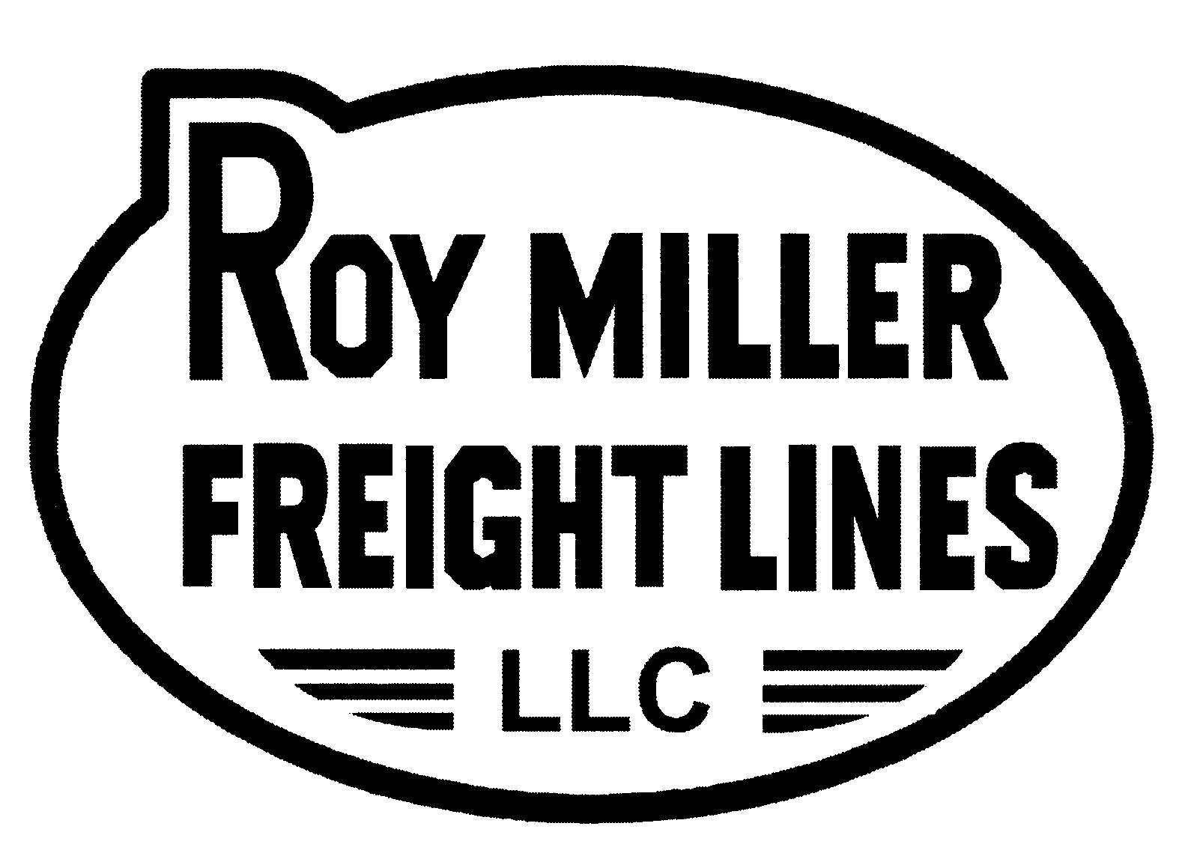

LETTER OF AUTHORITY

RMFL PRO NUMBER ____________________

Roy Miller Freight Lines is hereby directed to perform the actions indicated:

Return shipment to shipper*

Dispose of or destroy damaged freight*

Redeliver shipment to consignee

Re-consign shipment to:* ________________________________
________________________________
________________________________

Reverse payment terms from Collect to Prepaid*

Reverse payment terms from Prepaid to Collect (only allowable before shipment has been delivered and less than 30 days from date of pickup)*

Cancel COD*

Reverse COD fee payment terms from:
Collect to Prepaid or from
Prepaid to Collect

Perform inside delivery

Perform liftgate delivery service

Provide extra labor to deliver shipment

Perform weekend, holiday, or after hours delivery

*Only the shipper may authorize this

Unless otherwise indicated, the undersigned agrees to be responsible for the applicable charges.

AGREED TO
BY: ___________________________________
Company Name

___________________________________ ___________________
Signature Date

___________________________________
Printed Name

___________________________________
Title

