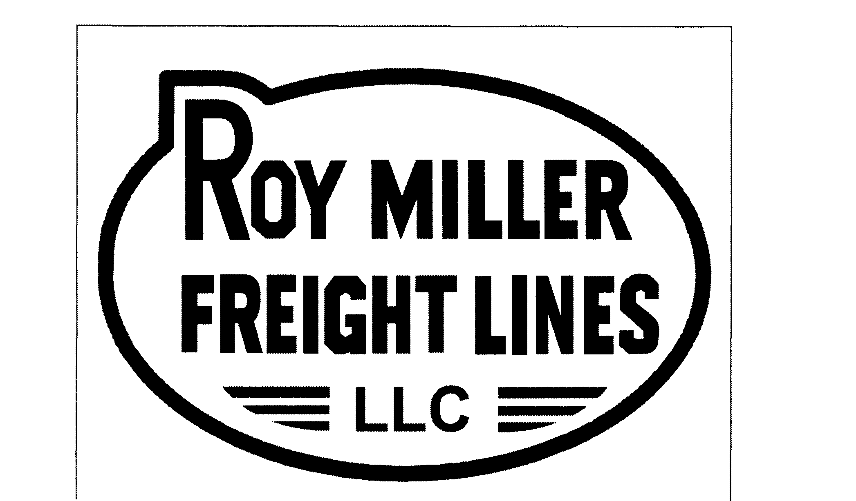 | Roy Miller Freight Lines  Freight Claim Department  P.O. Box 18419  Anaheim, CA 92817-8419  FAX # 714.237.1572

CLAIM FILED BY
Company Name | Claimant’s Claim No. | Date Prepared
Address or P.O. Number | RMFL DR # | Freight Bill Date
City, State, Zip | Claim is for  ___SHORT ___DAMAGE | Total Amount of Claim  $

CLAIM IS MADE WITH RMFL ON THE FOLLOWING DESCRIBED SHIPMENT
Consignee | Destination
Shipper | Orgin
Total No. of Pieces in Shipment | Total Weight of Shipment

DETAILS OF CLAIM SHOW HOW AMOUNT OF CLAIM IS DETERMINED
No. Pieces | Description of Articles | Amount
 | TOTAL | $

DOCUMENTS NEEDED IN SUPPORT OF YOUR CLAIM
LOSS: | DAMAGE:
Original or copy of paid freight bill | Copy of paid freight bill
Original Bill of Lading | Carrier’s inspection report (if inspected)
 | Original invoice or certified copy showing prices
 | Repair bill or certified copy (if repaired) showing material used & labor rate per hour

NOTE:
To expedite the handling of your claim please include the above mention documents as your claim WILL NOT BE PROCESSED until properly supported.

Claimant’s Signature: ____________________________

